Jose Dixon

10/15/2016

COSC 251.001_Fall 2016

Dr. Rahman

**Assignment 2**

***Question 1 – Without numpy***

**Source Code**

## Student 1

x = [95, 83, 96, 88, 78, 87, 90]

print x, "Student 1 test scores"

a = sum(x)/7

print [a] * 7, "Mean for Student 1"

c = [y - b for y, b in zip([95, 83, 96, 88, 78, 87, 90], [88, 88, 88, 88, 88, 88, 88])]

print c, "Test scores - mean for Student 1"

f = [e*d for d, e in zip([7, -5, 8, 0, -10, -1, 2], [7, -5, 8, 0, -10, -1, 2])]

print f, "(Scores - Mean)^ 2 for Student 1"

g = sum (f)

print "The sum for Student 1 scores is", g

h = (g / 7)**0.5

print "The standard deviation for Student 1 is " , h

print "The lowest grade for Student 1 is ", min(x)

print "The highest grade for Student 1 is", max(x)

i = max(x)-min(x)

print "The range for Student 1 grades is", i

## Student 2

j = [90, 60, 75, 82, 80, 65, 88]

print j, "Student 2 test scores"

k = sum(j)/7

print [k] * 7, "Mean for Student 2"

l = [m - n for m, n in zip([90, 60, 75, 82, 80, 65, 88], [77, 77, 77, 77, 77, 77, 77])]

print l, "Test scores - mean for Student 2"

o = [p*q for p, q in zip([13, -17, -2, 5, 3, -12, 11], [13, -17, -2, 5, 3, -12, 11])]

print o, "(Scores - Mean)^2 for Student 2"

r = sum (o)

print "The sum for Student 2 scores is", r

s = (r /7)**0.5

print "The standard deviation for Student 2 is", s

print "The lowest grade for Student 2 is", min(j)

print "The maximum grade for Student 2 is", max(j)

t = max(j)-min(j)

print "The range for Student 2 grades is ", t

**Output**

[95, 83, 96, 88, 78, 87, 90] Student 1 test scores

[88, 88, 88, 88, 88, 88, 88] Mean for Student 1

[7, -5, 8, 0, -10, -1, 2] Test scores - mean for Student 1

[49, 25, 64, 0, 100, 1, 4] (Scores - Mean)^ 2 for Student 1

The sum for Student 1 scores is 243

The standard deviation for Student 1 is 5.83095189485

The lowest grade for Student 1 is 78

The highest grade for Student 1 is 96

The range for Student 1 grades is 18

[90, 60, 75, 82, 80, 65, 88] Student 2 test scores

[77, 77, 77, 77, 77, 77, 77] Mean for Student 2

[13, -17, -2, 5, 3, -12, 11] Test scores - mean for Student 2

[169, 289, 4, 25, 9, 144, 121] (Scores - Mean)^2 for Student 2

The sum for Student 2 scores is 761

The standard deviation for Student 2 is 10.3923048454

The lowest grade for Student 2 is 60

The maximum grade for Student 2 is 90

The range for Student 2 grades is 30

***Question 1 – With numpy***

**Source Code**

import numpy as np

## Student 1

a1 = np.array([95, 83, 96, 88, 78, 87, 90])

print a1, "Student 1 test scores"

print [int(a1.mean())] * 7, "Mean"

print "The standard deviation for Student 1 is" , a1.std()

print "The lowest grade of student grades is", int(a1.min())

print "The highest grade for Student 1 is", int(a1.max())

a2 = int(a1.max()) - int(a1.min())

print "The range for Student 1 grades is", a2

a3 = np.percentile(a1, 75, interpolation='higher') - np.percentile(a1, 25, interpolation='lower')

print "The interquartile range for Student 1 is", a3

## Student 2

print "---------------------------------------------------------------------------------------"

b1 = np.array([90, 60, 75, 82, 80, 65, 88])

print b1, "Student 2 test scores"

print [int(b1.mean())] * 7, "Mean"

print "The standard deviation for Student 2 is", b1.std()

print "The lowest grade from student 2 is", int(b1.min())

print "The highest grade from Student 2 is", int(b1.max())

b2 = int(b1.max()) - int(b1.min())

print "The range for Student 2 grades is", b2

b3 = np.percentile(b1, 75, interpolation='higher') - np.percentile(b1, 25, interpolation='lower')

print "The interquartile range for Student 2 is", b3

v = min(b1.std(),a1.std())

print "---------------------------------------------------------------------------------------"

print "The students test scores that are more consistent is Student 1 because", v, " is smaller value closer to the mean."

**Output**

[95 83 96 88 78 87 90] Student 1 test scores

[88, 88, 88, 88, 88, 88, 88] Mean

The standard deviation for Student 1 is 5.89015089374

The lowest grade of student grades is 78

The highest grade for Student 1 is 96

The range for Student 1 grades is 18

The interquartile range for Student 1 is 12

---------------------------------------------------------------------------------------

[90 60 75 82 80 65 88] Student 2 test scores

[77, 77, 77, 77, 77, 77, 77] Mean

The standard deviation for Student 2 is 10.4256355946

The lowest grade from student 2 is 60

The highest grade from Student 2 is 90

The range for Student 2 grades is 30

The interquartile range for Student 2 is 23

---------------------------------------------------------------------------------------

The students test scores that are more consistent is Student 1 because 5.89015089374 is smaller value closer to the mean.

***Question 2 – Line Graph***

**Source Code**

import numpy as np

import pylab as pl

data = np.loadtxt("textdata.txt")

low_temp = data[:,0]

high_temp = data[:,1]

pl.plot([1, 2, 3, 4, 5, 6, 7, 8, 9, 10, 11, 12] , low_temp)

pl.plot ([1, 2, 3, 4, 5, 6, 7, 8, 9, 10, 11, 12], high_temp)

pl.xlim (0.8, 12.2)

pl.title("Average Temperatures in Baltimore--Line Graph")

pl.xlabel("Month")

pl.ylabel("Temperature")

pl.legend(["High", "Low"])

pl.xticks([1, 2, 3, 4, 5, 6, 7, 8, 9, 10, 11, 12], ["Jan", "Feb", "Mar", "Apr", "May", "Jun",

"Jul", "Aug", "Sep", "Oct", "Nov", "Dec"])

pl.show()

**Output**

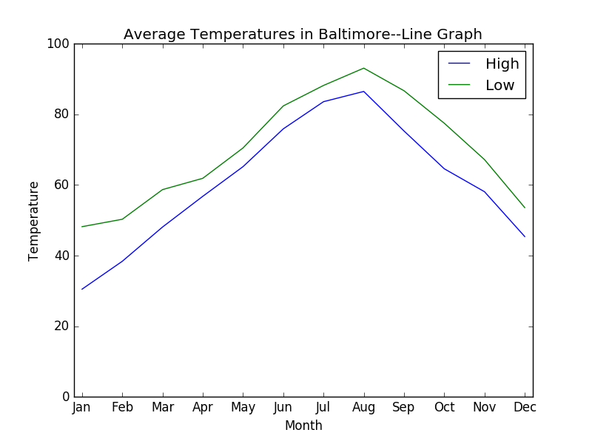

***Question 2 – Bar Graph for Low Temperatures***

**Source Code**

from matplotlib import pyplot

data = np.loadtxt("textdata.txt")

low_temp = data[:,0]

pyplot.bar ([1, 2, 3, 4, 5, 6, 7, 8, 9, 10, 11, 12], low_temp)

pyplot.title("Average Low Temperatures in Baltimore--Bar Chart")

pyplot.xlabel("Month")

pyplot.ylabel("Low Temperature Range")

pyplot.xticks([1, 2, 3, 4, 5, 6, 7, 8, 9, 10, 11, 12], ["Jan", "Feb", "Mar", "Apr", "May", "Jun", "Jul", "Aug", "Sep", "Oct", "Nov", "Dec"])

pyplot.show()

**Output**

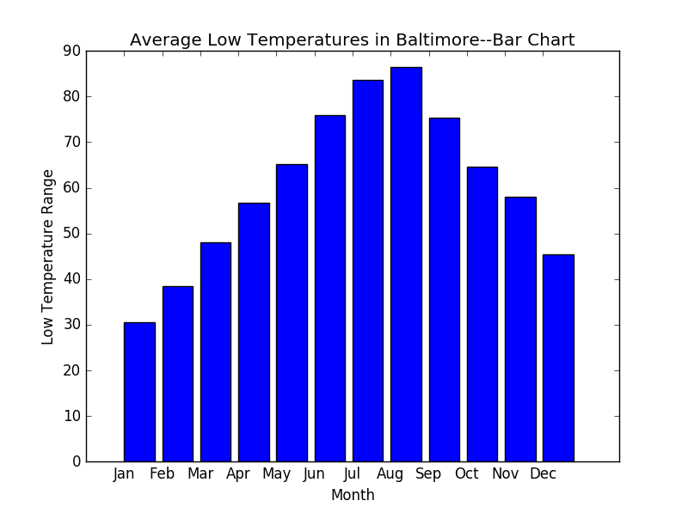

***Question 2 – Bar Graph for High Temperatures***

**Source Code**

from matplotlib import pyplot

data = np.loadtxt("textdata.txt")

high_temp = data[:,1]

pyplot.bar([1, 2, 3, 4, 5, 6, 7, 8, 9, 10, 11, 12], high_temp)

pyplot.title("Average High Temperatures in Baltimore--Bar Chart")

pyplot.xlabel("Month")

pyplot.ylabel("High Temperature Range")

pyplot.xticks([1, 2, 3, 4, 5, 6, 7, 8, 9, 10, 11, 12], ["Jan", "Feb", "Mar", "Apr", "May", "Jun", "Jul", "Aug", "Sep", "Oct", "Nov", "Dec" ])

pyplot.show()

**Output**

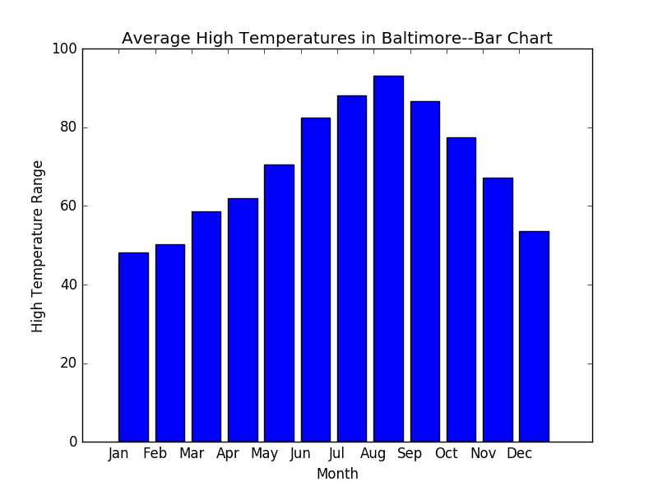

***Question 2 – Side by Side Graph***

**Source Code**

import numpy as np

import matplotlib.pyplot as plt

data = np.loadtxt("textdata.txt")

n_groups = 12

low_temp = data[:,0]

high_temp = data[:,1]

fig, ax = plt.subplots()

index = np.arange(n_groups)

bar_width = 0.35

opacity = 0.8

rect1 = plt.bar(index, low_temp, bar_width, alpha=opacity, color='red', label='Low')

rect2 = plt.bar(index + bar_width, high_temp, bar_width, alpha=opacity, color = 'purple', label='High')

plt.xlabel("Month")

plt.ylabel("Temperatures")

plt.title("Temperatures in Baltimore by comparison")

plt.xticks(index + bar_width,(["Jan", "Feb", "Mar", "Apr", "May", "Jun", "Jul", "Aug", "Sep", "Oct", "Nov", "Dec"]))

plt.legend()

plt.tight_layout()

plt.show()

**Output**

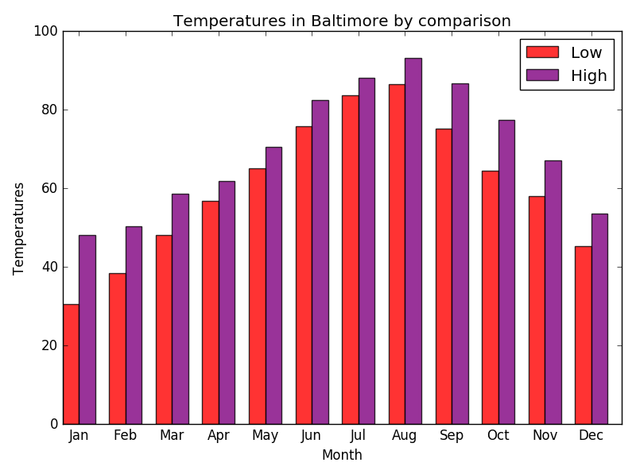***Question 3 – Writing data to text file***

**Source Code**

import sys

from __future__ import print_function

low1 = [30.5, 38.4, 48.1, 56.8, 65.2, 75.9, 83.6, 86.5, 75.3, 64.6, 58.1, 45.1]

high1 = [48.2, 50.3, 58.7, 61.9, 70.5, 82.4, 88.2, 93.1, 86.7, 77.5, 67.2, 53.6]

temp2 = low1 + high1

temp3 = "The lowest temperature is", min(temp2), "The highest temperature is", max(temp2), "The average temperature is", int(sum(temp2)/24)

log = open('finaldata.txt', "w")

print(temp3, file = log)

**Output** (from the txt. file)

(‘The lowest temperature is’, 30.5, ‘The highest temperature is’, 93.1, ‘The average temperature is’, 65)

